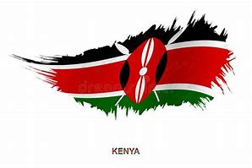
JUNIOR SCHOOL
KENYA JUNIOR SCHOOL EDUCATION ASSESSMENT
KJSEA
FORMATIVE ASSESSMENT

PRACTICAL ASSESSMENT
PRETECHNICAL STUDIES
MARKING SCHEME

- You have been provided with the following pictures of people in a certain career. Name the careers shown.
Engineer Technician Mason
- Identify the following metals and state their colour and uses.
Metal | Name | Colour | Uses
A | Aluminium | Shiny grey | Make utensils, iron boxes, pans, sufuria, aluminium sheets etc.
B | Iron | Dull grey | Make utensils, iron boxes, pans, sufuria, farm machineries, ironsheets,window frames.
C | Steel | Black | make rail bridges, rods, beams, sufurias, pans, cutleries etc
D | Copper | Shiny | making electric wires ,pipes, tanks, sinks etc
- You have been provided with the following materials.
- Ammeter
- Wires
- Bulb
- Switch
- Cell holder
- You are required to
- Make a complete circuit.
Teacher to ensure that the connection is appropriate and bulb lights.

- Draw a set up to demonstrate a complete circuit.

- Measure the amount of current passing through the circuit.
……………………………………….
- Draw hazard symbol that shows high voltage

- Check whether the following material are good or bad conductors of electricity.
Material | Conductivity status
U -plastic spoon | poor
V-aluminium spoon | good
W -dry stick | poor
X -piece of thread. | poor
Y- pen | poor
Z -iron nails/ pins | good

- The teacher has laid on the table the following non-metallic material.
- Identify samples ABCD
A Piece Of Animal Skin
B Fibres
C Cotton
D Plastic

- What is the use of the materials ABCD
A making drums, shoes, cloths etc
B making cloths, baskets, mats etc
C making cloths, hospital equipments,blankets etc
D making insulators, utensils, cases etc

- Identify the accident injury below

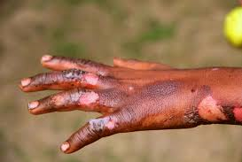 Burns

