Competence based curriculum

Grade 4

mathematics

MEASUREMENT

Working out the Perimeter of Plane Figures

Square

What is the perimeter of the figure below?
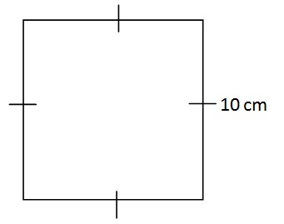
Perimeter is calculated by adding all the sides of the square.
Remember that all sides of a square have equal measurements
So, if One side is marked 10 cm, all sides are 10 cm
Perimeter = L + L + L + L or L x 4
= 10 + 10 + 10 + 10 (or 10 x 4) = 40
= 40 cm (do not forget the units)

Rectangle

What is the perimeter of the figure below?
Perimeter is calculated by adding all the sides of the Rectangle.
Remember that two opposite sides of a rectangle have equal measurements
So, if One side is marked 10 cm, the opposite side is also 10 cm.
Perimeter = L + W + L + W or (L x 2) + (W x 2) or 2L + 2W
= 18 + 10 + 18 + 10 or (18 x 2) + (10 x 2) = 56
= 56 cm (do not forget the units)

Other Figures

What is the perimeter of the figure below?
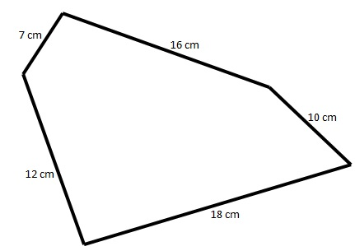
Perimeter is calculated by adding all the sides of the shape.
Draw the shape on a paper and mark each side when you add it. This will help prevent adding a side twice.
= 12 + 7 + 16 + 10 + 18 = 63
= 63 cm (do not forget the units)

Addition involving metres and centimetres
When working with metres and centimetres, always remember:
1 metre = 100 centimetres.

Example 2.1

Convert 16 metres to centimetres
Remember 1m = 100 cm
Hence,
16 m = ? cm
16 x 100 = 1600 cm.
1600 cm

Example 2.2

Wok out
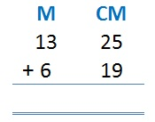

Answer
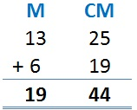

Example 2.3

Mary's drew a 1m and 30 cm line on the sand. John's drew 5m and 10 cm from where Mary left. How long was the line?

Answer
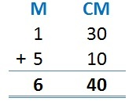

Subtraction involving metres and centimetres

Example 3.1

Wok out
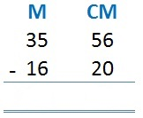

Answer
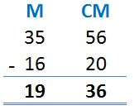

Example 3.2

A stick measured 3m and 16 cm. Mercy cut 1m and 50 cm from it. What was length of the remaining stick.
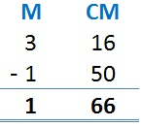
In this example, 16 is less than 50 and hence will leave a negative number. Hence, we 'borrow' 1 metre from the metres column, convert it to centimetres and add 16. It will be 116.
Therefore, 116 - 50 = 66.
On the metres column, we are left with 2 - 1 (remember we 'borrowed' 1m earlier)
2 - 1 = 1

Multiplication involving metres and centimetres

Example 4.1

Wok out
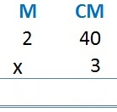

Answer
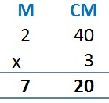
First, we multiply 40 by 3 to get: 40 x 3 = 120
Remember that 100cm = 1, hence the 120cm can be converted to metres to give 1m and 20cm
Write the 20 in the cm column and 'carry forward' the 1m.
Then multiply 2 x 3,
2 x 3 = 6,
Then add the 1 we had 'carried forward' earlier,
6 + 1 = 7m,
Hence the answer is 7m 20cm.

Division involving metres and centimetres

Example 5.1

Wok out
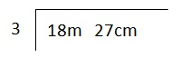

Answer
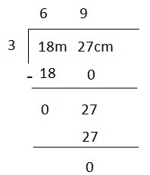
Your answer, 6m 9cm

Mass

Student's Activity 1
When you go the shop, you buy some items in terms of their mass. Some items are usually written how heavy they are.
For instance, Elizabeth found this packet of maize flour in her kitchen. What is mass of the maize flour when full?

Answer
You can also be asked: "How heavy was the packet of maize flour when full"
As indicated on the packet, when full of maize flour, it has a mass of 2 kilograms.
Mass can be given in terms of grams (g) or kilograms (kg).
Always remember that 1000 grams (g) = 1 kilogram (kg)

Addition of Mass Involving Kilograms

Practice 1
Mary bought 5kg of maize flour and 2kg of sugar. How many kilograms of maize flour and sugar did she buy?

Answer
Maize flour: 5kg
Sugar: 2kg
5 + 2 = 7kg

Practice 2
Our teacher went to the market and bought the following items:
- Maize flour: 2kg
- Wheat flour: 2kg
- Sugar: 1kg
- Rice: 2kg
- Beans: 2kg
How many kilograms of items did she buy altogether?

Answer
2 + 2 + 1 + 2 + 2 = 9kg

Subtraction of Mass Involving Kilograms

Practice 1
Work out the following:
30 kg - 13kg

Answer
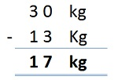
Answer: 17kg

Practice 2
Jecinta bought 35kg of maize flour and gave 16kg to her sister. How many kilograms of maize flour was she left with?

Answer
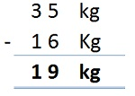
Answer: 19kg

Money
When dealing with money, always note:
1 shilling (sh) = 100 cents (cts)
so
100 cents = 1 shilling

Practice 1
Convert the following into cents
a) 5 shillings
b) 75 shillings

Answer
a) 5 shillings
Every shilling is 100 cents, so:
This can also be represented as:
5 x 100 = 500 cents
b) 75 shillings
75 x 100 = 7500 cents

Practice 2
Convert the following into shillings
a) 200 cents
b) 650 cents

Answer
Remember that 100 cents = 1 shillings
Therefore we divide the amount given in cents by 100 to get amount in shillings
a) 200 cents
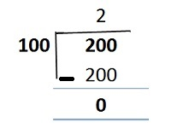
2 shillings
b) 650 cents
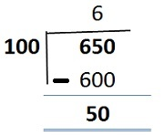
6 shillings 50 cents

Addition Involving Money

Practice 3
Work out
1000 + 550

Answer
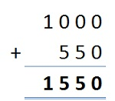
Answer: Sh. 1550

Practice 4
Add 50 shillings 60 cents and 14 shillings and 30 cents
This can also be written as:
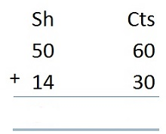

Answer
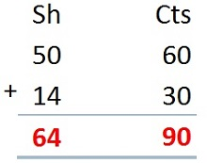

Practice 5
Work out the following:
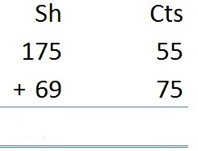

Answer
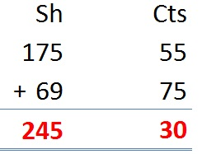
Hint:
- When adding the cents, always remember that 100 cents = 1 shilling.
- In the question above, 55 cents + 75 cents = 130 cents.
- Since 130 cents is more than 100, we convert 130 cents into shillings.
- 130 cents ÷ 100 cents = 1 shilling 30 cents.
- We 'carry' the one shilling to the shillings side and add it.
175 + 69 + 1 = 245.
Answer: Sh. 245 30 cts

Subtraction Involving Money

Practice 6
Work out the following:
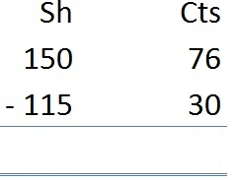

Answer
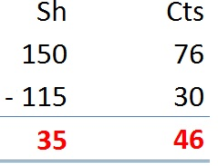

NUMBERS

Numbers: Place Value and Total Value

1. Place Value
a. This is the position of a digit in a number
b. It is given in words
c. The place value is identified from the right side

Place Value Chart
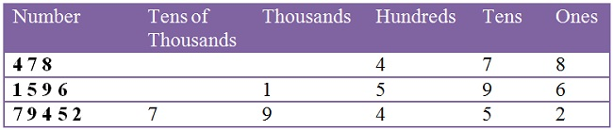

Practice Question 1
If you have a number like 97234, the place value of 2 would be?

Answer
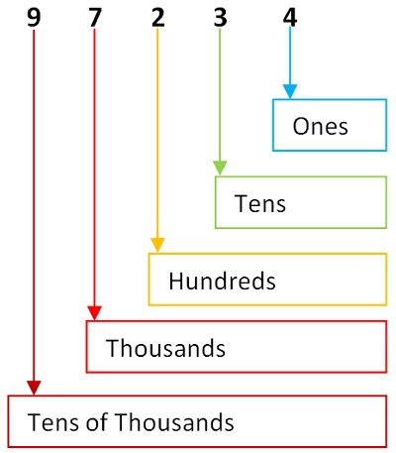
Counting from the right, the place value of 2 is hundreds.
In the same number, the place value of 9 is tens of thousands.

2. Total Value
a. It is shows the quantity and value of digit in a number
b. It is given in words or symbols
c. One has to first identify the place value before the total value
d. Digits to the right hand of the digit are replaced with zeroes to give the total value.

Practice Question 2
The total value of 7 in the number 17264 is obtained as follows.

Answer
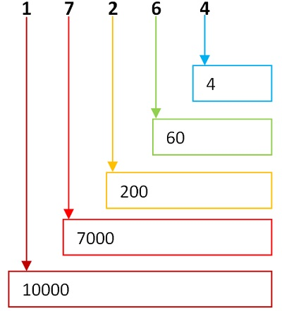
The place value of the number 7 is thousands.
All the numbers to the right of 7 are replaced with zeroes, and the ones before 7 are ignored.
Therefore, the total value of 7 is 7000

Practice Questions
In the number 52831, the total value of 5 is 50000
In the number 11809, the total value of 8 is 800
In the number 1236, the total value of 1 is 1000

Practice Questions
What is the place value and total value of 5 in the following numbers
- 62159
- 54782
- 95124
- 12015

Numbers: Arranging Numbers

1. Arranging from smallest to largest
It is arranging numbers from the one with the least value to one with the highest value.

Practice Question 1
Arrange the following numbers from smallest to largest; 598, 601, 399, 248, 733.

Answer
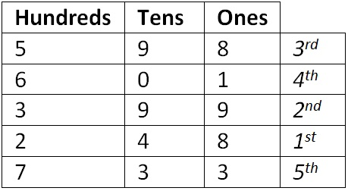
The digits in the hundreds (place value) are 5, 6, 3, 2, and 7.
When arranged from smallest to largest, the numbers are 2, 3, 5, 6, 7.
Then, the correct order is 248, 399, 598, 601, 733.

Practice Question 2
Arrange the following numbers from smallest to largest; 528, 557, 501, 590, 538.

Answer
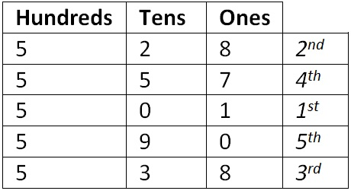
The digits in the hundreds (place value) are the same, so we consider the tens column.
When arranged from smallest to largest, the numbers are 0, 2, 3, 5, 9.
Then, the correct order is 501, 528, 538, 557, 590.

2. Arranging from largest to smallest
It is arranging numbers from the one with the highest value to one with the least value.

Practice Question 3
Arrange the following numbers from the largest to the smallest; 847, 748, 487, 874,784.

Answer
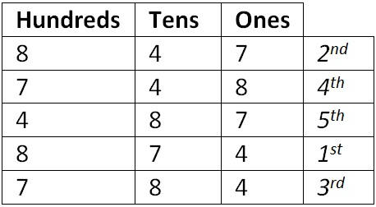
First, we consider the hundreds column, the numbers are grouped as 8, 8, 7, 7, 4.
Since number 8 and 7 occur more than once, we consider the tens column.
We can arrange them as: 87, 84, 78, 74, 48
Therefore, the answer is 874, 847, 784, 748, 487

Numbers: Rounding off numbers to the nearest ten

Rounding off numbers to the nearest ten up to 1000

Important Notes
a. When rounding off a number to the nearest ten, you look at the digit in the place value of ones.
b. If this digit is 0, 1,2, 3, or 4, the digit in the place value of tens remain the same, while the digit in the ones place value becomes zero.
c. If the digit in the ones place value is 5,6,7, 8 or 9,add 1 to the digit in the place value of tens, and the digit in the place value of ones becomes zero.

Practice Question 1
Round off 34 to the nearest tens;

Answer
The digit in the ones place value is 4.
Therefore, the digit in the tens place value (3) remains the same and the one in the ones column changes to 0.
The answer is 30.

Practice Question 2
Round off 47 to the nearest tens;

Answer
The digit in the ones place value is 7.
Therefore, we add 1 to the digit in the tens place value and the digit in the ones place value becomes 0.
The answer is 50

Practice Question 3
Round off 396 to the nearest tens;

Answer
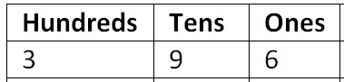
The digit in the ones place value is 6.
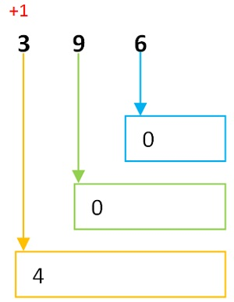
Therefore, we add 1 to the digit in the tens place value and the digit in the ones place value becomes 0.
Since the digit in tens column is 9, on adding the 1, we get 10, where we write 0 and carry 1 to the number in the hundreds column, which is 3.
The answer is 400

More rounding-off examples
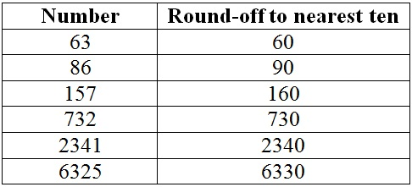

Practice Questions
Round-off the following numbers to the nearest ten.
- 126
- 215
- 111
- 982
- 659

ALGEBRA

Using Letters to Form Algebraic Expressions
We use letters in the alphabet to form algebraic expressions. These letters are from a to z.
Everything can be represented in terms of letters.
For instance, we can use:
t to represent tables
b to represent boys
g to represent girls
a to represent books

Forming Algebraic Expressions

Practice 1
Using the letters given above, form an algebraic expression to show:
3 boys + 5 girls

Answer
Boys are represented by the letters b and girls by the letters g.
Hence
3 boys = b + b + b = 3b
5 girls = g + g + g + + g + g = 5g
3b + 5g

Question 1
Use different letters to write an algebraic expression to show:
a) 4 books + 6 pens
b) 10 chairs + 2 tables
c) 1 desk + 4 books

Show your answers to your teacher/parent/guardian.

DATA HANDLING

Representing Data using Frequency Tables

Activity 1
Count the number of spoons, plates, and cups in your home.
John, a Grade 4 pupil counted the following:
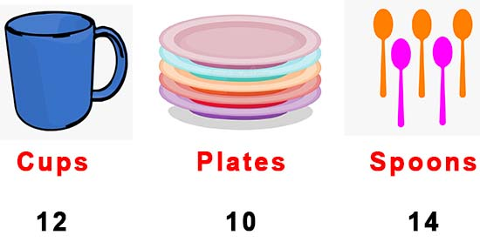
John counted:
12 cups
10 plates
14 spoons
This information can be represented as follows:
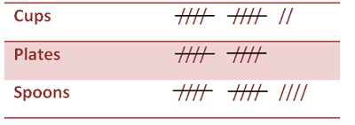
Hint:
Count the number of 'lines'. Each '/' is counted as 1 as shown below
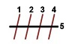

Practice 1
Grade 4 students did an exam and scored as shown in the table below:
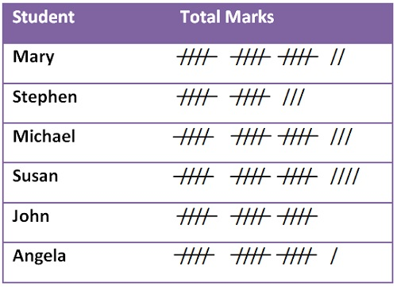
Using the information above, how many marks did each student score?

Answer
- Mary: 17
- Stephen: 13
- Michael: 18
- Susan: 19
- John: 15
- Angela: 16

Interpreting Frequency Tables

Practice 2
The table below shows the number of men and women who went to the hospital in the month of May.
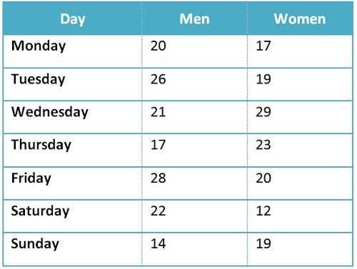
a) On which day were the number of men who went to the hospital the highest?
b) On which day were the number of women who went to the hospital the lowest?
c) How many men visited the hospital on Monday, Tuesday, and Wednesday?
d) How many women visited the hospital from Monday to Sunday?
e) How many people went to the hospital on Friday, Saturday, and Sunday?

Answers
a) On which day were the number of men who went to the hospital the highest?
Friday. 28 Men went to the hospital that day.
b) On which day were the number of women who went to the hospital the lowest?
Saturday. 12 women went to the hospital on Saturday.
c) How many men visited the hospital on Monday, Tuesday, and Wednesday?
Monday: 20
Tuesday: 26
Wednesday: 21
Hence; 20 + 26 + 21 = 67 men
d) How many women visited the hospital from Monday to Sunday?
Monday: 17
Tuesday: 19
Wednesday: 29
Thursday: 23
Friday: 20
Saturday: 12
Sunday: 19
Hence; 17 + 19 + 29 + 23 + 20 + 12 + 19 = 139 women
e) How many people went to the hospital on Friday, Saturday, and Sunday?
Men
Friday: 28
Saturday: 22
Sunday: 14
Total = 28 + 22 + 14 = 64
Women
Friday: 20
Saturday: 12
Sunday: 19
Total = 20 + 12 + 19 = 51
Total People: 64 + 51 = 115 Men and Women

