ART AND CRAFT GRADE 1 NOTES
Drawing

1.0 Lines
What is a line?
A line is a continuous improvement mark made on a surface

Types of lines
There are different types of lines: straight,zigzag,wavy, horizontal, curved, vertical, diagonal, thin thick lines.
Show Learners a chart with different types of lines.

Standing or vertical line

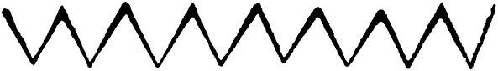
Zigzag line

DIAGONAL LINE

DOTTED LINES
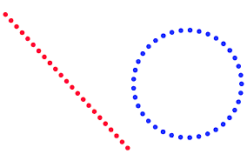

CURVED LINES

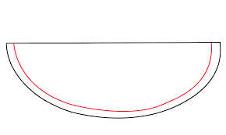

Positions of straight lines
Draw a right angled triangle on the Black board or Manila paper and show it to the Learners.
Explain to the Learners the three positions of a straight line on the triangle. The three positions are: vertical, horizontal and diagonal line.
Activity:
Let Learners draw different types of lines that they have learnt in groups and let them display their work.

Shapes
A shape is an area enclosed by lines.
Types of shapes
- square

- rectangle

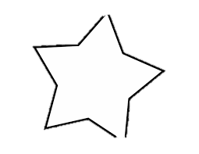
- Star shape

Let Learners name the shapes and identify lines making the shapes in groups
Drawing regular shapes
Guide the Learners to draw the shapes by use of free hand.
Drawing a square
- Draw upper and lower horizontal straight lines first and they should be equal.
- Join the two horizontal lines by drawing vertical lines at both ends.
- Tell the Learners that the four lines should be equal.
Draw a triangle- by emphasizing the diagonal vertical and horizontal positions of a straight line.

Draw a circle by joining the curve line facing up and curve line facing down.
Let Learners do an extended activity of drawing a star
Drawing irregular shapes
Irregular shapes are shapes that do not have dimensions (length, width, height)E.g stones,trees,hills.
-show Learners picture of irregular shapes.

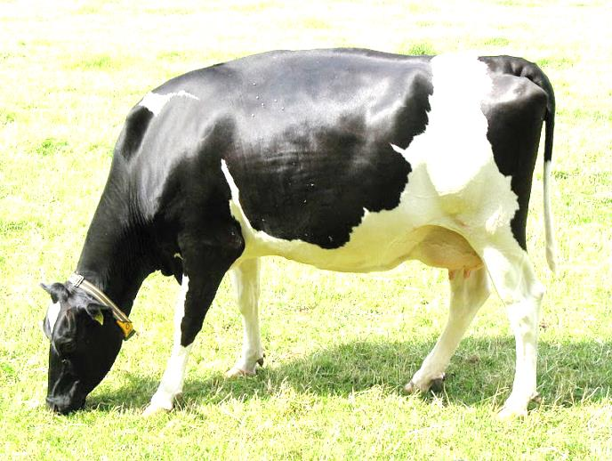

Tree
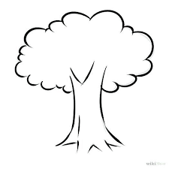

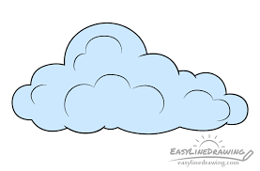
cloud

Texture
Texture is the roughness or smoothness of a surface.
It is also defined as the feel of a surface whether rough or smooth.
Guide Learners to look at pictures of texture in the pupils books
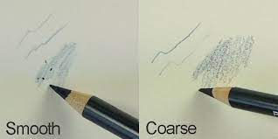

Teaching texture:
1. Introduce the lesson by having Learners brush their palms together and ask them how it feels when touching palm.
2. Bring something with rough texture such as a khaki bag or the back of a tree and ask Learners to touch. Ask them how they feel.
3. Observe the Learners reactions when they touch smooth and rough surfaces
4. Teach that the surface of the palm is smooth texture and the surface of the khakibag or back of a tree is rough texture.
5. Let Learners touch various surfaces and ask them which texture is this?
Creating smooth and rough textures in the physical and ICT environments
- Learners can create textures by rubbing over varied surfaces on pieces of pieces of paper using crayons,pencils or charcoal sticks.
- To create smooth textures Learners should put papers over smooth surfaces then rub
- To create rough textures Learners to put papers over rough surfaces then rub.
- Let Learners do activities of creating more textures on their own.

Topic 2: PAINT AND COLOURS
Making improvised brushes.
What is a brush?
A brush is a tool used to pick and apply paint on a surface. And we can improvise a brush with locally available materials.
Identifying and collecting tools and materials for making a brush.
- Divide the Learners into groups of four
- Guide Learners to collect materials they can use to make a brush
- Materials used to make a brush are; piece of old cloth,sponge,sisal,fibre,palm fibre, coconut fibre, feathers and green sticks depending on the ones available near the school.
Improvising a brush using locally available materials.
Demonstrate to Learners how to prepare the materials for improvising a brush in steps
- First cut the green sticks to an average size of a pencil
- Cut to size of your choice material for the bristles.The material here can be a sponge,old cloth,sisal fbre,palm fibre, coconut fibre or feather.

- Once you have the right size of bristles tie it to the chopped side of the green stick using a string or a thin wire.
- Make several brushes from the different materials which you can test to see which produces the best paint job.
- Guide Learners to each make a brush from the materials of their choice.
- Let Learners display their brushes and talk about them.

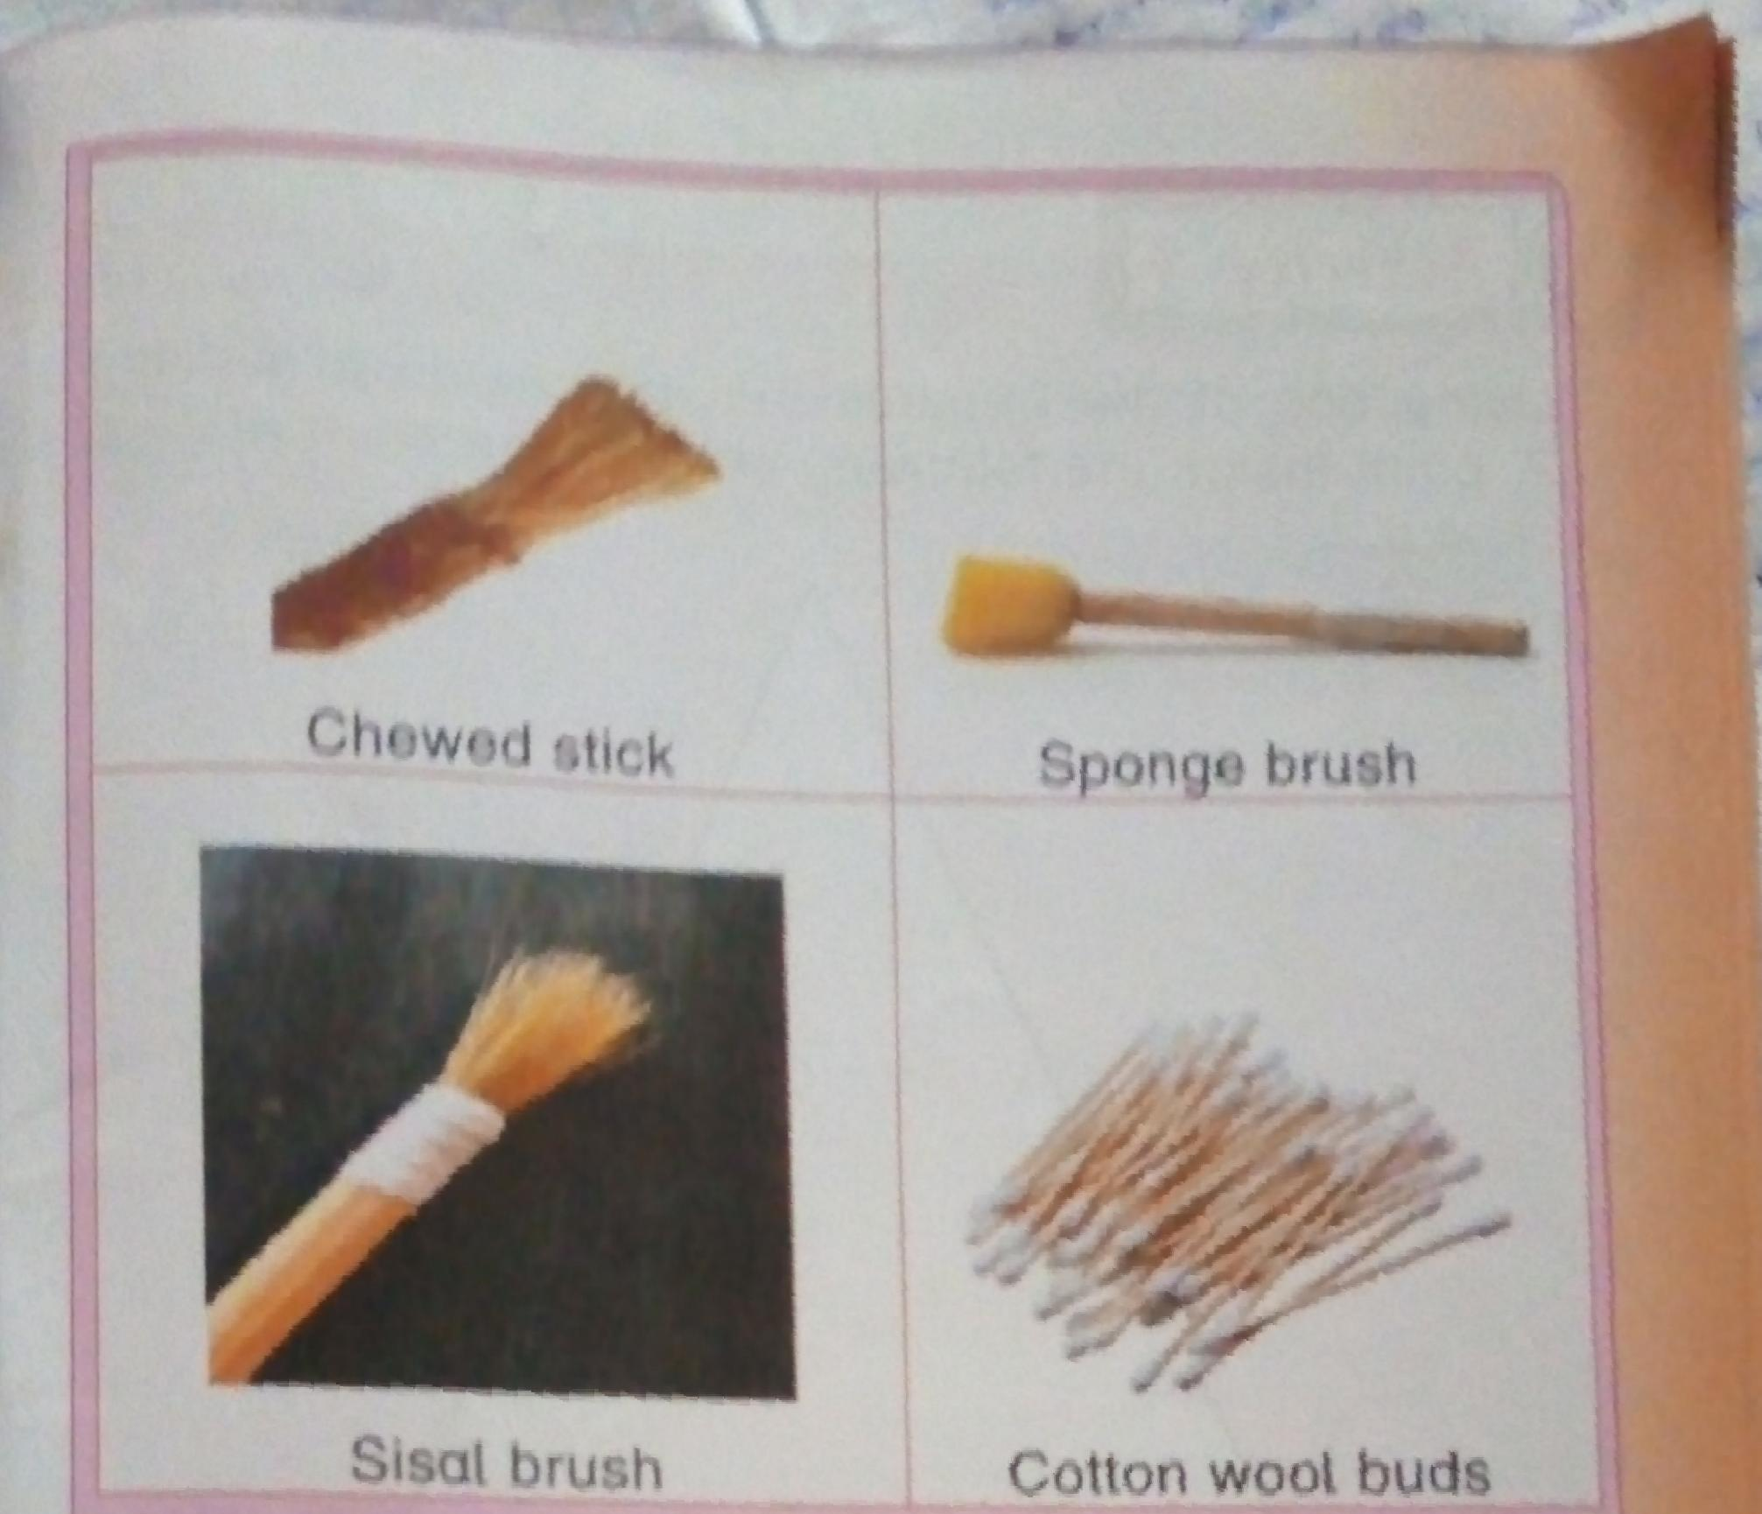

Topic 3: Pattern Making
What is a pattern?
A pattern is a repetition of lines,dots,shapes and even colours over and over on a surface
Line pattern line pattern is when a pattern is created using lines.
- Identifying line patterns in the environment.
- Ask Learners to look around the classroom and see if they can see any objects with lines repeated,let them write their names.
- Guide them to tour the environment around the school and write down the names of the objects with lines repeated over and
Over
Creating line patterns
- Let Learners choose the pattern they want to create.
- They should use different linesto create patterns
- They can use charcoal or crayons to create the patterns.

Examples of line patterns
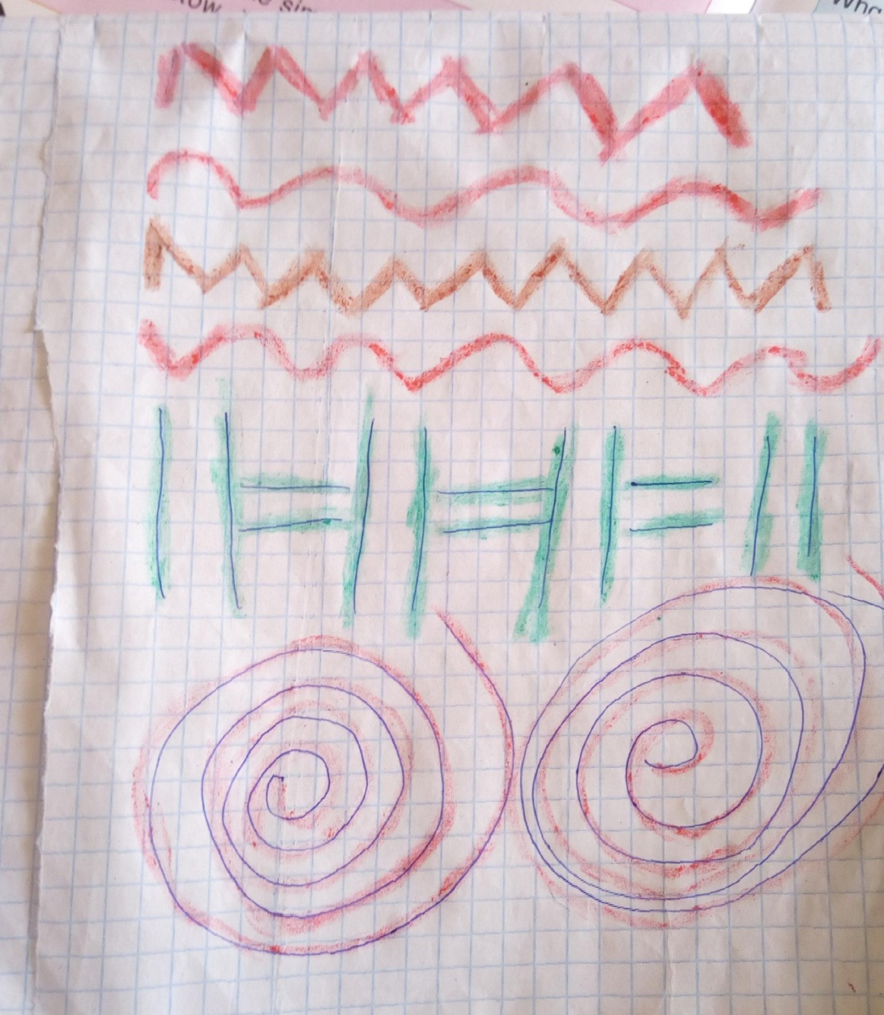

Dot patterns when a pattern is created using dots it’s called dot pattern.
This is a dot pattern.
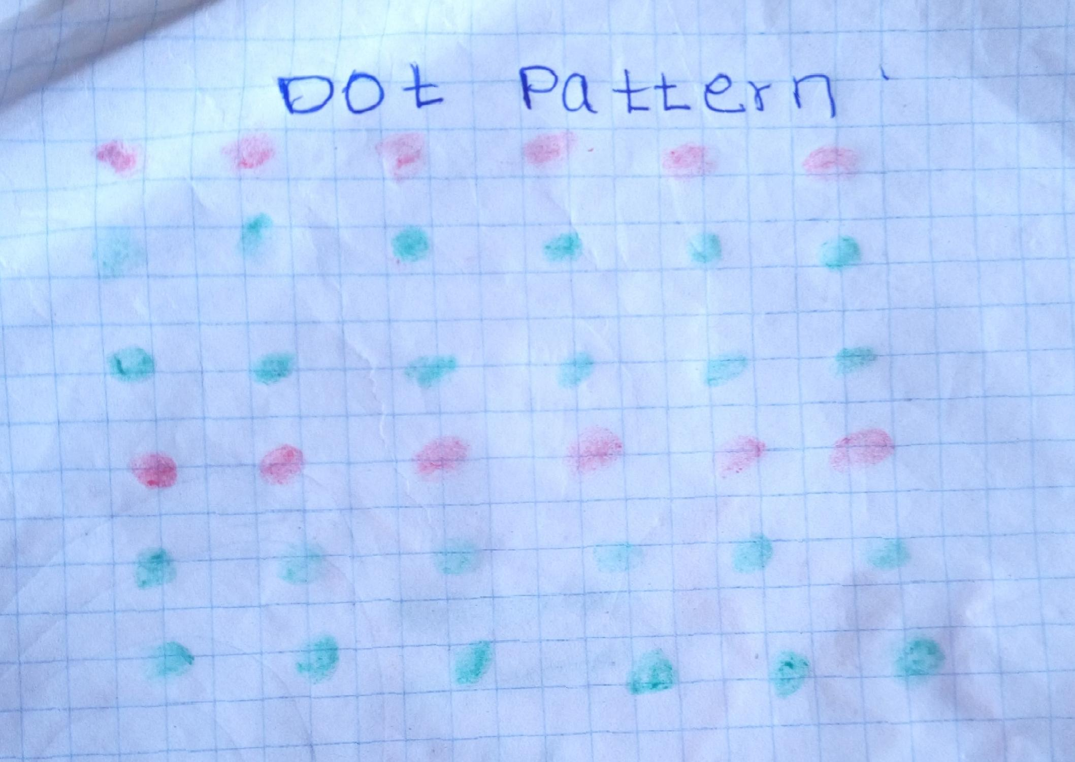

Identifying dot patterns in the environment
- Let Learners look around the classroom.
- What objects can you see around with dot patterns.let them write names of the objects
- Take a tour to the environment around the school
- Let Learners identify any objects with dot patterns and write their names
- Guide Learners to create dot patterns in their books
- They can use pencils, brushes, charcoal or crayons.
- They can use different colours of their choice to create patterns.
Numerical pattern
When a pattern is created using numbers,it is called numerical patterns

Creating a number pattern
1.Guide Learners to identify numbers in the classroom.
2.Let Learners identify numbers by writing them down
3. Display a chart of number patterns for Learners to observe and familiarize with number patterns.
4.Write numbers on the Blackboard and let Learners write numbers repeatedly to make patterns.
5.Let Learners display their work and talk about it.

Topic 4: Paper Craft.
What is paper craft?
-Paper craft is making items from papers.This can can be done through cutting,teariy, folding, rolling or twisting.
Paper Craft is mainly done for decoration.
NB you can Google pictures of items made of paper craft and show them to Learners.
Safety rules to check when making paper craft.
1.Do not throw or poke pairs of scissors or blades at each other.pass them on carefully.
2. Do not put pairs of scissors or glue to your mouth.
3. When playing with paper items outside,do not aim at each other’s face.Throw them away from each other.
Rolling technique
Making decorative items out of paper using rolling technique.
  - Collect the materials for use like papers, newspapers, cutting tools such as scissors,rulers,adhesives or glue and pencils.You can ask Learners to bring the materials from home.
  - Demonstrate to the Learners how to go about the rolling technique.
  - Take one page of the newspaper.From the of the newspaper roll it around the stick tightly.
  - Pull out of the stick when the whole paper has been rolled.
  - Make many more folds together with the Learners.Make sure all Learners are keeping the same pace so that none is left behind.
  - Let the Learners display the paper craft and express their feelings
Get the pictures of paper craft created by rolling technique from the internet and show it to the Learners.
Twisting technique
Making twisted paper decoration for window and wall display.
- Display pictures of twisted wall decorations or let Learners look at the pictures in the pupils book
Materials needed.
-Glossy paper, coloured paper,a pair of scissors and cellotape.
-You can recycle some of these materials from the environment.
-Collect and prepare them a day before the lesson.
Procedure
- Cut strips of coloured glossy paper 3cm by 30 cm
- Use a pair of scissors to stretch and pull the paper strips
- Take a piece of paper and twist it till it becomes a twisted strip
- Release the paper strips to cause twisting
- Join the pieces using cellotape to make a long piece of decoration craft.
- Hung your decoration on Windows or walls for beatification

Folding technique
Making a paper decoration.
- First take Learners for a digital tour of the internet to observe variousp paper decorations made using folding technique.

