NAME……………………………………………………………..SCHOOL……………………………..
ADM NO……………………..INDEX NO………….…………...DATE…………………...…………….
SIGN……………………..….CLASS…………………………….STREAM……….……………………

312/1.
GEOGRAPHY.
PAPER 1.
SEPTEMBER 2021.
Time: 2 ¾ Hours.
TERM ONE 2021 CaSPA AMUKURA PARISH EXAM
Kenya Certificate of Secondary Education (K.C.S.E)

INSTRUCTION TO CANDIDATES:

- This paper has Two Sections A and B.
- Answer all questions in sections A.
- In section B answer questions 6 and any other two questions.
- All answers must be written on the answer sheet provided

This paper consists of 4 printed pages
Candidates should check the question paper to ensure
that all the pages are printed as indicated and no questions are missing .

SECTION A
Answer all questions in this section.
1. a) Explain the origin of the earth and the solar system according to the Nebula cloud theory.
(4mks)
b) Name two other theories that explain the origin of the earth and the solar system apart from the Nebula cloud theory. (2mks)

2. a) List two zones of transition in the atmosphere. (2mks)
b) Give three evidences that the interior of the earth is hotter. (3mks)

3. a) Define the following terms.
i) River divide (1mk)
ii) A confluence (1mk)
iii) A river profile (1mk)
b) List three factors that influence the formation of a river. (3mks)

4. How is an oasis formed? (4mks)

5. List four characteristics of Mediterranean climate. (4mks)

SECTION B: Answer questions six and any other two questions.
6. (a) Study the map of Kijabe 1: 50,000 sheet 134/3 provided and answer the following questions

(i) Give the approximate height of peak of Kijabe hill. (1mk)
(ii) Measure the length of the Naivasha –Nairobi railway line from landhies (Grid ref 257987) to
the level crossing near Kijabe station (grid reference 308984). Give your answer in kilometers and
Meters.) (2mks)
(iii) Name the relief feature on the map that may have created problems during the construction of
the railway line. (1mk)

(b) Describe the drainage of the area covered by the map extract. (5mks)

(c) Explain how relief has influenced the distribution of settlement in the area covered by the
map extract. (4mks)

(d) Citing evidence from the map, state four economic activities carried out in the area

covered by the map extract. ( 4 mks)

(e) Suppose you were to carry out a field study at Wakangwe forest:

(i) Design a working schedule that you would use during the day of the study. (5mks)
(ii) Give reasons why it would be necessary to sample part of the forest for the study. (2mks)
(iii) State two ways in which your findings would be useful to the local community. (2mks)

7. a) i) What is faulting? (1mk)
ii) With the use of a well labeled diagram explain how a reverse fault occurs. (5mks)
iii) State two other types of faults apart from reverse faults. (2mks)
b) Describe how a rift valley forms through tensional forces. (4mks)
c) Explain three ways in which features resulting from faulting are of economic importance to man. (6mks)
d) You intend to carry out a field study of the landforms around your school.
i) State two hypotheses you are likely to formulate for the study. (2mks)
ii) Apart from dividing your class into groups, in what three other ways will you
prepare for the study. (3mks)
ii) In what two ways is dividing the class into groups important? (2mks)

8. a) i) Differentiate between intrazonal and azonal soils. (2mks)
ii) Give three examples of a zonal soils (3mks)
b) i) Explain four factors that influence soil formation. (8mks)
ii) Give two factors that determine the colour of soil (2mks)
c) i) What is soil erosion. (2mks)
ii) Explain four ways in which vegetation prevents soil erosion. (8mks)

9 a) i) Name a country in Africa where temperate grassland is found. (1mk)
ii) State four characteristics of temperate grasslands. (4mks)
b) i) Explain four ways trees in the coniferous forests have adapted to the
environmental conditions of the region. (8mks)
c) You are required to carry a field study on a forest near your school. Describe the methods
you would use to determine each of the following aspects of the trees in the forest.
i) Age of the trees. (3mks)
ii) Height of the trees. (3mks)

iii) Tree species (3mks)

10. The figure below shows underground zones of saturation. Use it to answer question a (i)
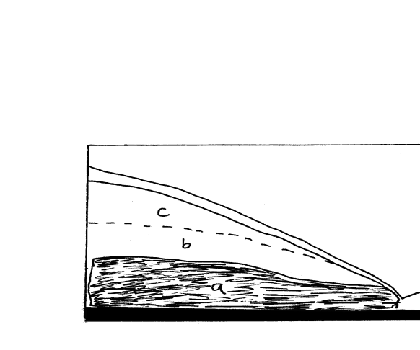
a) i) Identify the zones marked a, b, and c. (3mks)
ii) Name four sources of groundwater. (4mks)
b) Explain four ways in which groundwater is of significance to human activities. (8mks)

c) i) Give two examples of lakes in East Africa that have formed due to crustal
warping. (2mks)
ii) Describe how the process of crustal warping leads to formation of lakes. (5mks)
iii) State three other processes that lead to formation of lakes apart from crustal
warping. (3mks)

